Website Planning Document

Company: The Mountain Spoke

Location: Bozeman, Montana

Business: Bike Shop, Tours, and Services

Site Purpose:

To provide a fresh new experience to Mountain Biking in Bozeman Montana, we are trying to provide product, services/repairs, trail/tour information, and special events for everything mountain bikes.

Target Audience:

* Bike Enthusiasts/Athletes
* All Skill levels
* Ages 10+
* Male and Female
* Any type of bikes

Typography:

Roboto: This will before the whole website because it provides contrast for titles, paragraphs, headers, and the name of the company.

* Light: Will be used for body text and footer
* Regular: May be used for body text if Light does not work
* Medium: Links and important words and smaller headers(column or row names or labels)
* Bold: Headers of Sections and for Navigation
* Black: Company Name and Navigation if Bold doesn’t work

Color Scheme:

* Macintosh HD:Users:Marci:Desktop:Screen Shot 2017-12-01 at 11.49.17 AM.png Dust - #e5bf7c / 229, 191, 124 – highlights info
* Macintosh HD:Users:Marci:Desktop:Screen Shot 2017-12-01 at 11.48.13 AM.png Orange - #f79029 / 247, 144, 41 – Links
* Macintosh HD:Users:Marci:Desktop:Screen Shot 2017-12-01 at 11.49.02 AM.png White - #ffffff / 255, 255, 255 – Background for site
* Macintosh HD:Users:Marci:Desktop:Screen Shot 2017-12-01 at 11.48.51 AM.png Black - #010101 / 1, 1, 1 – Main body of text color
* Macintosh HD:Users:Marci:Desktop:Screen Shot 2017-12-01 at 11.48.40 AM.png Grey - #736e72 / 115, 110, 114 – Navigation and Footer bar (possible Borders)

Logo & Sitemap:

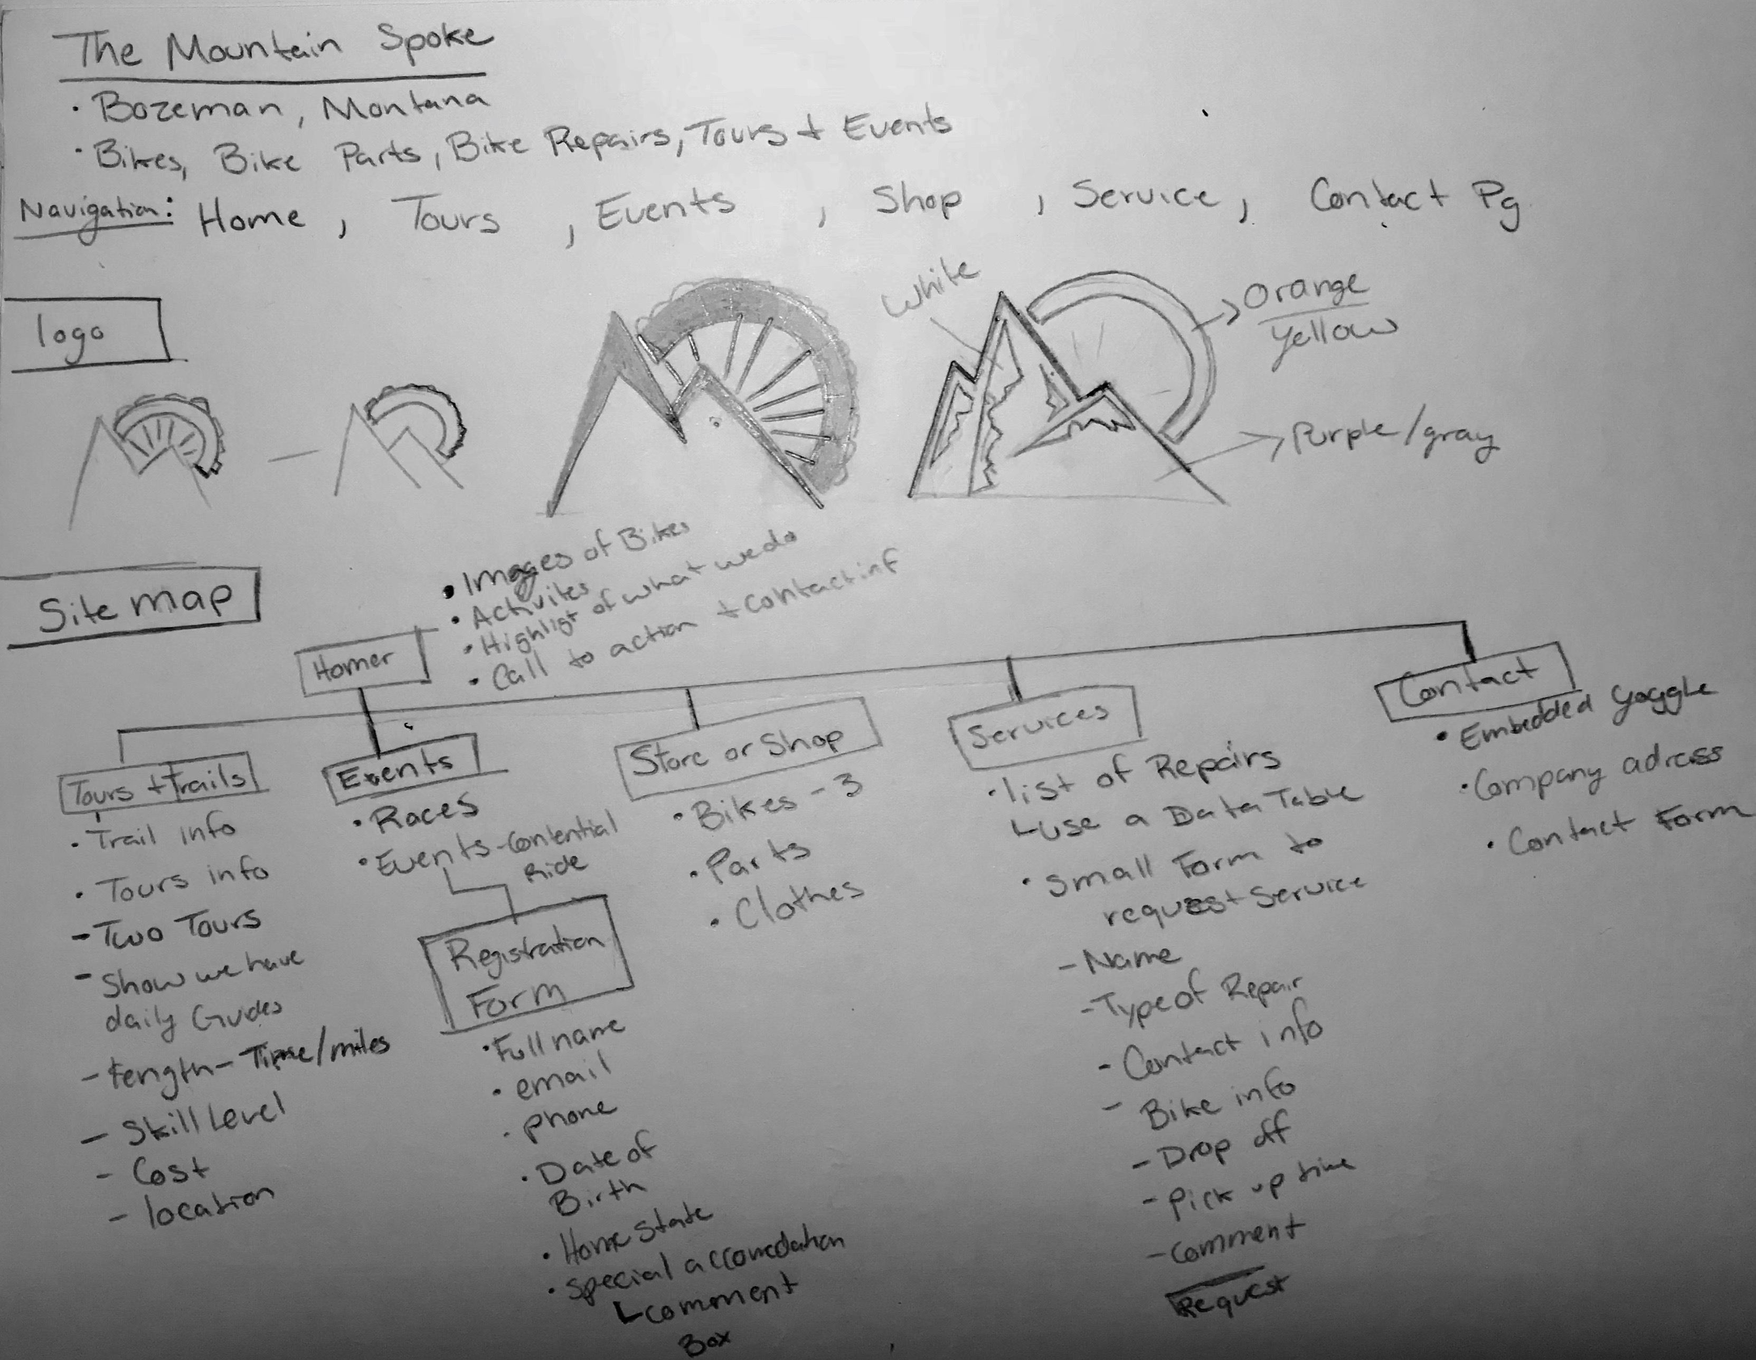

Wire Frame: I want my Small Page to be one column and my Medium and Large Page to have 3 columns

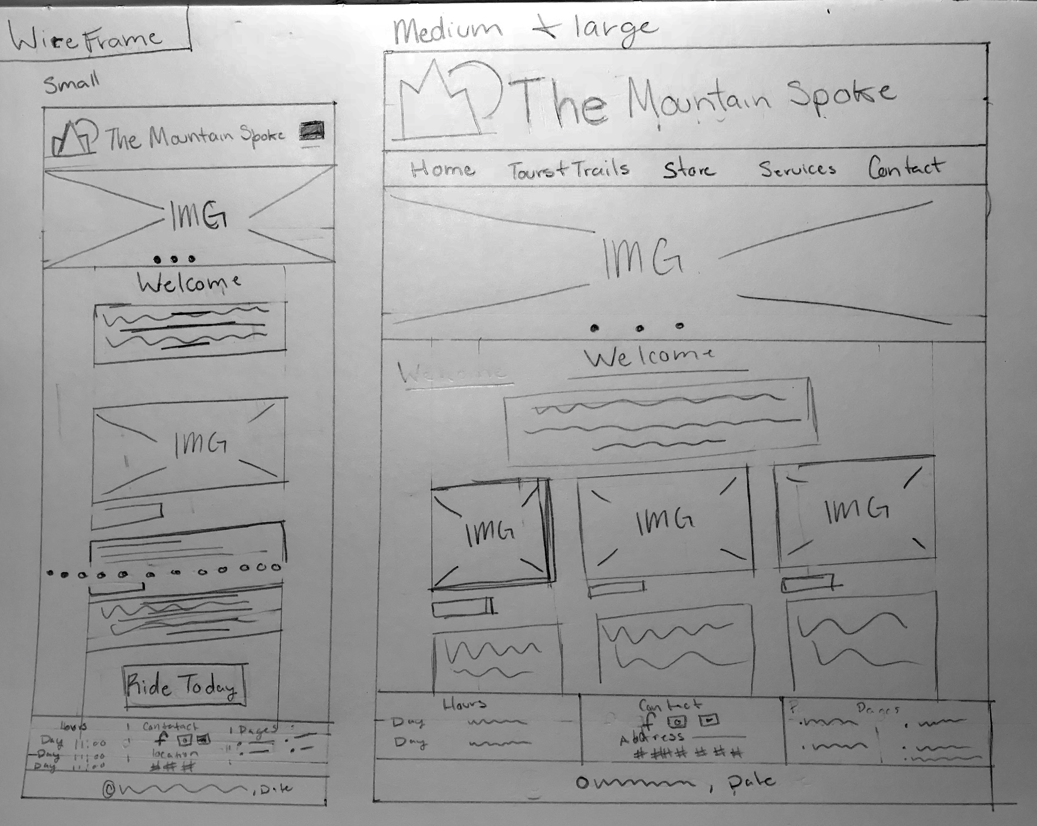

Website:

<https://fonts.google.com/specimen/Roboto>

examples:

<https://www.owenhousecycling.com/>

<https://www.singletracks.com/Mountain-Bike-Trails-bike-trails_0.html?filterBy=%7Cloc:45.679722~-111.037778~25~Bozeman%2C+MT>

<https://www.mtbproject.com/directory/8009008/bozeman>

<https://www.giant-bicycles.com/us/contend-sl-1-disc>

<https://www.giant-bicycles.com/us/talon-3>

<https://www.giant-bicycles.com/us/trance-3>

<https://www.adventurecycling.org/routes-and-maps/adventure-cycling-route-network/great-divide-mountain-bike-route/>